Ideation Phase
Empathize & Discover
Date | 10 July 2026
Team ID | [Your Team ID]
Project Name | House Rent — Broker-Mediated Real Estate Platform
Maximum Marks | 4 Marks
Empathy Map Canvas:
To design a moderation-first marketplace, the team built an empathy map for our primary persona: a first-time renter relocating to a new city, who represents the core anxieties any renter, buyer, or owner feels when dealing with an unmoderated listings platform.
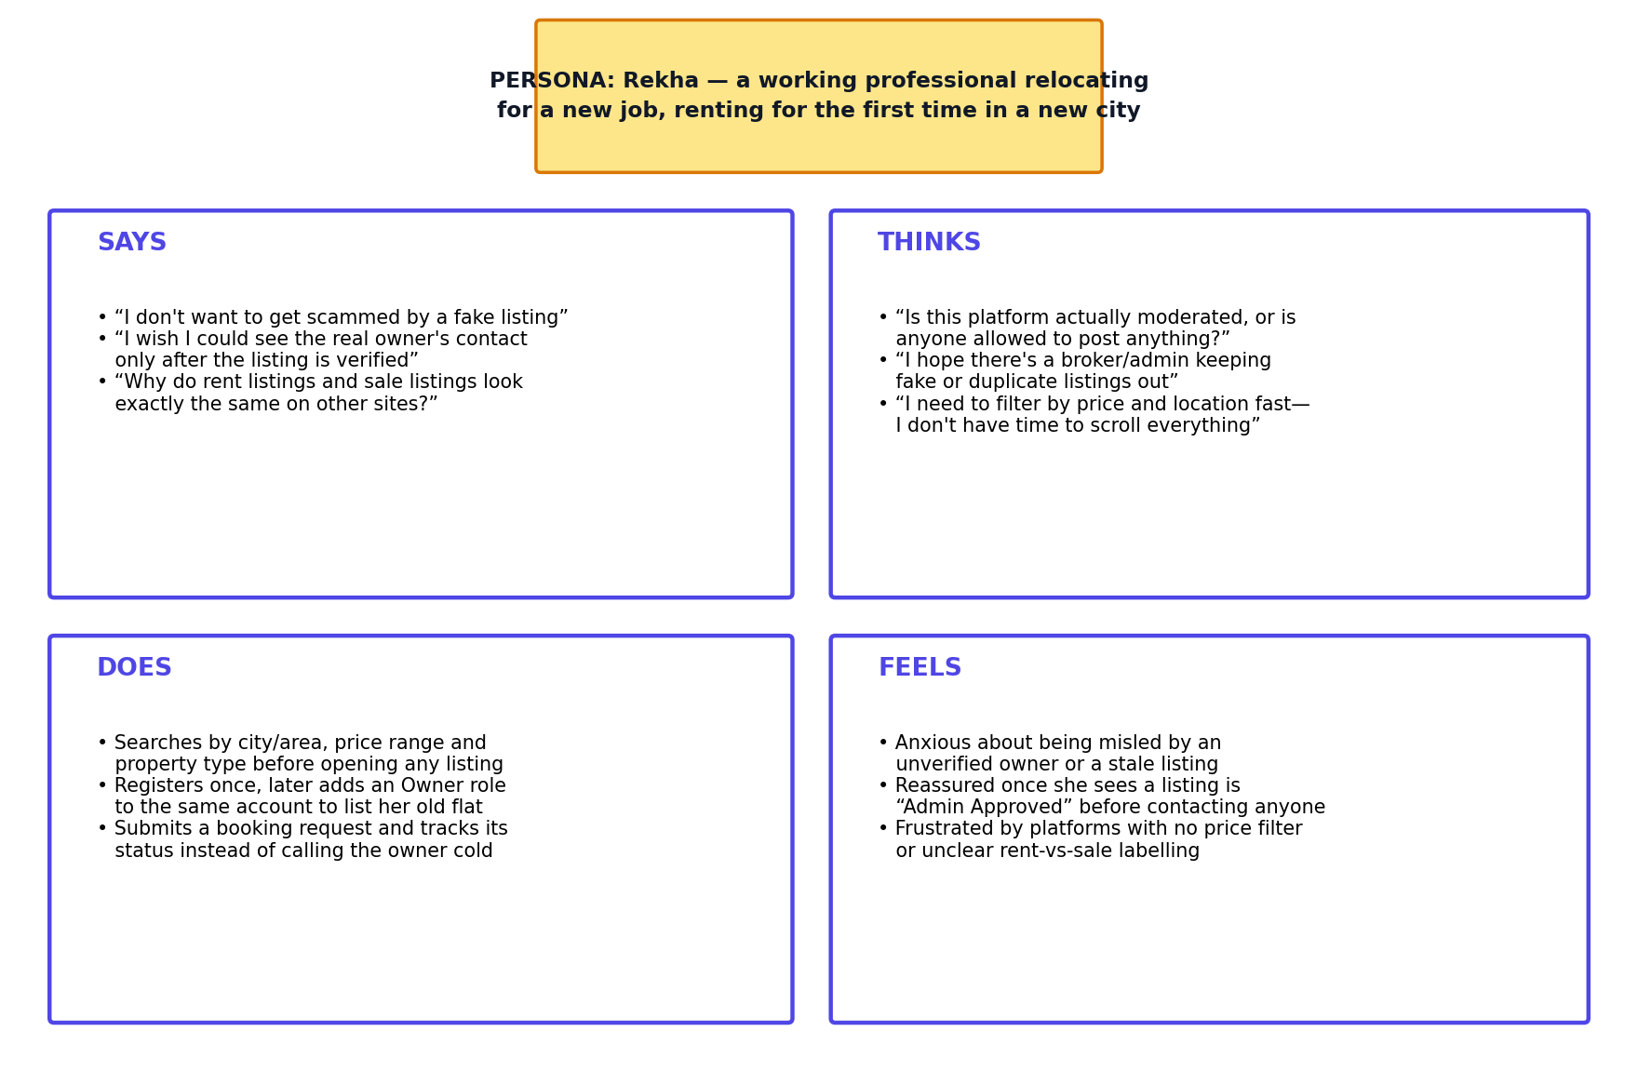
Figure: Empathy Map — Rekha, a first-time renter
Key Insights Drawn from the Map:
- Trust is the #1 blocker — users repeatedly express fear of scams and fake listings more than any UI complaint
- An explicit “Admin Approved” signal reduces anxiety more than any amount of extra listing detail
- Search efficiency (price, location, type) matters as much as trust — users won't wait to filter manually
- Owners and renters are often the same person over time (e.g. renting out an old home while renting a new one), which directly motivated the dual-role account design

